 | 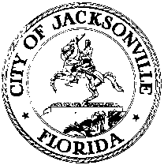
 | OFFICE OF THE CITY COUNCIL
ANNA LOPEZ BROSCHE  PRESIDENT  JACKSONVILLE CITY COUNCIL |  | SUITE 425, CITY HALL  117 WEST DUVAL STREET  JACKSONVILLE, FLORIDA 32202
OFFICE (904) 630-1452 |  | E-MAIL: CLBROWN@COJ.NET
FAX (904) 630-2906
TASK FORCE ON OPEN GOVERNMENT -AGENDA

APRIL 17, 2018
1:00 pm

- Introductions
- Legislative Process
Peggy Sidman, Office of General Counsel
- Best Practices- Transparency in City Government
Ethics Director Carla Miller
- Land Use and Zoning
Councilwoman Boyer
- Closing Comments
Survey questions
- Public Comment

Chairs: Hank Coxe and Dr. Sherry Magill
Members: Ywana Allen
Rachael Fortune
The Honorable Alberta Hipps
Ron Littlepage
Michael Lockamy
Audrey Moran
The Honorable Jim Overton
Sabeen Perwaiz
Cleve Warren

